COVID-19 Brimacombe
Intermediate/Building Stage 2 Safety Plan

This intermediate/building safety plan will guide the AMPEL Director and occupants in Brimacombe, including those who are members of the Stewart Blusson Quantum Matter Institute, directed by Andrea Damascelli, to continue or resume research activities in the building. This plan includes a review of common areas to ensure effective controls are in place to prevent the spread of COVID-19. The document reflects current government guidance and notices which can be found, along with information about UBC’s response to the pandemic at. https://covid19.ubc.ca/. More specific references are given below.

Name of Building | Brimacombe
Address of Building | 2355 East Mall

Table of Contents

Updates for Restart in Stage 2 2
Introduction 4
Reference Documents 4
General Procedures 4
Application for Restart in Stage 2 6
Office Use for Faculty and Researchers 7
Common Area Plans 7
Communication Plan 10
Hours 10
Monitoring and Enforcement 11
Emergency Procedures 11
Responsibilities 12
List of Units Occupying the Building 13
Appendix: 14
Building drawings showing rooms that will be unused in Stage 2

Updates for Restart in Stage 2

The following revisions have been made to the Brimacombe Intermediate/Building Safety Plan for Stage 2:

- Under Stage 2 maximum building occupancy will be allowed to increase, providing the physical distancing (2 m) requirement is maintained, to a maximum of 2/3 of normal occupancy. Faculty, staff and graduate students who are able to work off campus must continue to do so, so that the campus building occupancy is minimized.
  - The maximum occupancy based on the 2/3rds rule is 390 (of 585 regular occupants).
  - Maximum occupancy also considers physical distancing limits, which are typically the limiting factor. As a result, based on physical distancing limits and closure of many shared spaces, maximum occupancy will be below 200 in Stage 2. The exact number will be the sum of the maximum occupancy of each individual space.
  - A fob access system is used to monitor total building occupancy and estimate occupancy of individual spaces. In cases where the occupancy is exceeded, the Director will work with building occupants to reduce numbers.
  - Nearly all of the occupants of the building are researchers or research support staff. Most of the 21 administrative staff will work outside the building.
- PIs requesting an increase in lab staffing and/or access to on-campus resources from Phase I to Stage 2, must submit a Stage 2 amendment for review and approval by a member of the Local Safety Committee, the Director of AMPEL, and their Department Head, with input from the Co-Chairs of the Local Safety Team, and, where matters concern SBQMI, The Director and Operations Manager of SBQMI.
- Research labs will be able to operate at higher capacity as long as physical distancing (2 m) can be maintained between all researchers. Each space must continue to have the occupancy limits posted. High COVID risk situations, as identified in the Child/Amendment will require special review. PIs should consider equitable access to all their research personnel requiring on-campus resources. The decision tree in Appendix A will be used by PIs to prioritize the return to campus.
- New trainees (undergraduates, graduate students, post-docs) will be permitted to join research groups and obtain training. When training is required that cannot be performed with physical distancing, then researchers must follow safety regulations for close-up training activities (refer to the SRS resource: UBC Employees COVID-19 Essential In-Person Meetings/Trainings Guidance.)
- Weekend work that does not conflict with custodial services will be allowed. The aim here is to spread out the use of equipment and resources, and lab and building occupancy. On weekends, researchers should not use building common areas, except for the washroom nearest their lab. Researchers will be responsible for cleaning high touch points (e.g., light switches, door handles, tap handles, etc.) Weekday working hours of 7 AM to 6 PM will apply on weekends too.
- Shared office space for faculty, graduate students and post-docs can be used occasionally with special permission, but only by 1 person at a time. PIs requesting office use for their personnel must contact the Director prior to submitting an amendment request. Revised safety plans must include a user sanitizing checklist of high touch points in the office.
- Researchers and other employees who feel uncomfortable returning to the workplace are encouraged to raise their concerns with their Supervisor or Manager. The Applied Science COVID-19 Safety Plan is designed to manage safety risks associated with COVID-19 within the Faculty. Should an individual believe that they are at elevated risk as a result of an underlying medical condition or other concern, the Supervisor or Manager should consult with their Faculty Relations Senior Manager or HR Advisor.
- As a general rule, in-person meetings will not be permitted. An exception will be considered if there is a critical need (e.g., safety training that cannot be done online.) In that case, a safety plan for the activity with a layout of the room that ensures physical distancing will need to be reviewed and approved at the Faculty level.
- Occasional use of faculty offices may be permitted particularly where working from home is difficult, and for those who require on-campus resources and/or a teaching space for the upcoming academic term. No in-person office meetings will be permitted. Requests are made through the Stage 2 amendment.
- It is anticipated that only staff required for research and building operations (e.g., shops, technical facilities, supplies, shipping and receiving) will be on campus in Stage 2.
- A building-wide, fob-based reservation system, which was implemented at the start of Phase I to track building occupancy, will continue to be used in Stage 2. Weekly reports will be produced to track hourly occupancy for each day.
- Occupants will be asked to complete the Thrive BC Self-Assessment Tool before entering the building. Details of the operation are in the APSC parent plan.

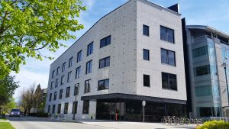
Introduction
The Brimacombe building is home to the Advanced Materials and Process Engineering Laboratory (AMPEL), which includes the Stewart Blusson Quantum Matter Institute (SBQMI). The building is primarily a research facility, but also houses the SBQMI administration. There are no classrooms. Researchers are from the faculties of Science and Applied Science, mostly in Physics, Electrical Engineering, Materials Engineering, Mechanical Engineering and Materials Chemistry.
Reference Documents
The following guidance documents and resources on the Safety & Risk Services COVID-19 Website were used in the development of this plan: Prevention, Working Safely on Campus including Personal Protective Equipment, Using Non-Medical Masks, and UBC Employee COVID-10 Guidance document, in addition to the BC CDC website on masks, physical distancing and other practices. Building services provides custodial services, whose specific procedures are outlined here. Other documents relevant to working on campus are Risk Assessment and Safe Work Procedure and Essential in Person Training and Guidance.

General Procedures
The following general procedures align with guidelines set by the BCCDC to prevent the spread of COVID-19. Please describe how some or all of the methods below will be used in this Building plan:
This document provides supplementary site-specific instructions for implementing the guidance provided in the documents listed above. The underlying principle is to promote safe working conditions through reduced building occupancy, physical distancing, surface cleaning and personal hygiene. No one may visit or work onsite without the express written permission of their immediate supervisor and director. The building will be open to researchers and research support staff from 7 AM to 6 PM Monday to Friday on a limited basis, subject to pre-approval of a Child Plan. Since all labs have already been approved for Phase I, this Child Plan will include the Phase I Workspace Safety Plan plus a (stage 2 amendment that modifies the Phase 1 Workspace Safety Plan – also known as the Return to Research Plan), including a list of authorized personnel and clear plans for implementing physical distancing and sanitation in laboratories and other workspaces. In Stage 2, access on weekends (and after hours in general) is possible with approval. Weekend hours will be 7 AM to 6PM. Weekend and afterhours occupants should not make use of building common areas, except washrooms closest to their lab. It is understood that those granted onsite permission will carry out tasks that cannot be done elsewhere. Time spent onsite must be kept to a minimum. It is expected that those who do not have permission to work onsite will continue to work remotely. Occupants will maintain a minimum of 2 m distance unless specifically excused from doing so, with measures proposed for mitigating risks. Traffic flow in common spaces in the building is arranged in order to allow for such physical distancing. Tape and signage are provided in hallways, stairs, common areas and washrooms in order to ensure that traffic flow and distancing rules are clear. UBC Custodial Services cleans common areas and washrooms once a day on weekdays, provides soap and paper towels in the washrooms, and refills the two hand sanitizer stations at each of the two main entrances to the Brimacombe building (East Mall and Engineering Lane). In addition to custodial staff cleaning, disinfectant spray bottles (TRITON HAND SANITIZER 80% ALCOHOL 20L PAIL) plus paper towels, are provided (by AMPEL and SBQMI) in common areas including the lunchroom (211), the seminar room (311), and common areas on each floor. Meeting rooms remain closed for the duration of Stage 2. Personal protective equipment (nitrile gloves, face shields and goggles) will continue to be worn to protect researchers and staff from hazards in laboratory environments. Occupants of the building may wear cloth or disposable, non-medical grade masks. Face shields, gloves, goggles and a mask will be worn when occupants need come within 2 m of each other in order to perform critical research tasks where such proximity is unavoidable (e.g. filling of liquid nitrogen dewars). Any operations at close quarters will require special permission – as outlined in the Workspace approval document.

Before coming to UBC, all employees, students and visitors must monitor their health status. If you are feeling unwell in any way, do not come in, and follow medical advice. COVID-19 affects different people in different ways. Most infected people will develop mild to moderate illness and recover without hospitalization. According to WHO,
Common symptoms:
- fever
- dry cough
- tiredness
Less common symptoms include:
- aches and pains
- sore throat
- diarrhea
- conjunctivitis
- headache
- loss of taste or smell
- a rash on skin, or discoloration of fingers or toes
Serious symptoms include:
- difficulty breathing or shortness of breath
- chest pain or pressure
- loss of speech or movement
If you are experiencing any of these symptoms, use the BC Health Self-Assessment tool to determine if you require further testing or medical care: https://bc.thrive.health/. No one with symptoms should leave their home. If you develop symptoms while at work, you are to leave immediately for home where you are to self-isolate and monitor your symptoms and/or seek medical attention in accordance with Public Heath directives. You may return to work once your symptoms resolve. Follow instructions on reporting in below section.

Physical Distancing Onsite in-person interactions must maintain a minimum physical distance of 2 m. All persons working onsite must practice physical distancing -- be mindful, respectful and patient when interacting with others of the 2 m rule. In circumstances where physical distancing cannot be maintained, supervisors must put in place other protective measures (refer to SRS UBC Employee COVID-19 Physical Distancing Guidance.)

Other General Considerations

Surface Cleaning Users are expected to wipe down any frequently touched surfaces before and after use with spray disinfectant or wipes. Disinfectant spray and paper towels will be provided in shared spaces. It is the responsibility of the PI for each lab to provide adequate supplies for their lab. (AMPEL and SBQMI have established a stock of common sanitization supplies and PPE for purchase by individual groups.) Surfaces include benchtops, handles, chairs, knobs, switches, tabletops, multiuser equipment, desktops, shared computers and instruments, etc.

Hand Washing/Sanitizing Hand sanitizer is provided at the main building entrances and exits. You must sanitize your hands when entering or leaving the building. Wash/sanitize your hands frequently and anytime you move between areas; i.e., from lab, office, and common areas. Avoid touching your face.

Wearing Nonmedical Masks All persons must wear an appropriate mask (defined below) when inside buildings on UBC Premises unless: 1) you are the sole occupant of an enclosed room; 2) one of the exceptions outlined in Attachment “A” apply; or 3) an approved COVID-19 Safety Plan has been implemented that provides specific guidance regarding the use of masks. An appropriate mask must have three layers of tightly-woven fabric (cotton or linen), or be a commercially produced three-layer disposable non-medical mask, and securely fit, without gaping, over the nose and mouth with ties or ear loops. For more information on appropriate masks please see https://srs.ubc.ca/covid19/health-safety-covid-19/.

Working from home, physical distancing or the use of engineering solutions such as physical barriers are the first lines of defense. Masks are effective only when used in combination with frequent hand-cleaning. Guidance on the wearing of medical and non-medical masks is available from UBC (see reference above) and Public Health Canada for non-medical wearing masks. It is critical that masks not be worn if may adversely affect health. Note that if persons must work in close proximity, then they must obtain approval from the Local Safety Team (contact Gary.Lockhart@ubc.ca ). Such activities may be allowed if there is wearing face shields in combination with a well fitted non-medical mask, along with googles, and lab coats or gowns. Please follow instructions found in the reference on the handling and disposal of PPE, lab coats and non-medical masks, as they may otherwise put the user and others at greater risk.

Social Interactions: Occupants should minimize social interactions in the building. Maintain physical distancing when interactions are required. Speak quietly, cough or sneeze into your elbow, and away from others, and practice frequent hand washing. Please remember always to “be kind, be calm and be safe” (Dr. Bonnie Henry.)

Application for Restart in Stage 2
Unless a change is requested, principal investigators will continue to operate under their approved Phase I Workspace Safety Plans and VPRI occupancy agreements. PIs desiring to increase lab occupancy, weekend (or afterhours) access, or office use, must provide a completed Child Plan (Stage 2 Amendment to their Phase 1 Workspace Safety Plan) to the Director of AMPEL. The Brimacombe Local Safety Team Co-chair or other LST member will evaluate the plans. Plans approved by the LST members must also be approved by the AMPEL Director, and by the relevant department head.
In Stage 2 consideration should be given to providing equitable access to all research personnel, such as can be achieved through a schedule or multi-day rotation. The plans will need to be consistent with maintaining the physical distancing (2 m) requirement and building occupancy below 2/3 normal load. Forms and approval procedures will follow those of the Faculty to which the lead principal investigator submitting the form belongs. Records of the application documents and procedures will be kept, and available for presentation to WorkSafe BC and others as needed. Workspace plans will be posted by researchers on the main entrances of all laboratories, along with occupancy limits. PIs will maintain records of occupancy over Stage 2, along with certificates of training for all members. The building will also keep paper copies of occupancy of the building during Stage 2, until 2 weeks following the end of Stage 2, at which point the records will be shredded, unless they are needed for an official investigation or for contact tracing.

For shared facilities including the SBQMI/AMPEL Nanofab, an application will be made by the lead PI or director of the facility. The procedures will be evaluated on the same criteria as for individual workspaces. For example, as in regular laboratories, booking procedures should be arranged to ensure clear physical distancing. In addition, each user should have their own personal protective equipment, and a separate location to store it. Where gowns are used, a cleaning procedure should be specified. The responsibilities of users, staff and administrators should be described: this should include responsibilities for monitoring, discipline, and cleaning. In Stage 2, training of new users will be allowed. When training is required that cannot be performed with physical distancing, then researchers must follow safety regulations for close-up training activities (refer to the SRS resource: UBC Employees COVID-19 Essential In-Person Meetings/Trainings Guidance.)

Office Use for Faculty, Researchers and Staff
In Stage 2, some limited access to offices may be granted for faculty, graduate students and post-docs. Offices may be used by only 1 person at a time no matter the room size. No in-person office meetings will be permitted. Faculty occupancy will be restricted to 25% on any given day. Office use may be permitted if it is clear that either: working effectively off-campus is difficult, or; facilities that are only readily accessible within their offices or the building are needed. Prioritization for office approval will be based on the following ranked list (1 = top priority):
1. Faculty and Staff who are acting Floor Wardens or have similar duties;
2. Faculty who have challenging off-campus working environments and who do not have access to office space in other locations;
3. Faculty who are physically participating in experiments in their labs – particularly early career researchers;
4. Other faculty members with a justification for working on campus.
If the number of approved requests exceeds 25% of the total number of faculty offices, an online booking system will be used to ensure that the 25% occupancy maximum is respected.

Occupancy of shared researcher offices (non-faculty) will be scheduled and monitored through online booking systems. For shared offices, PIs are expected to provide sanitizing supplies, while users are responsible for cleaning common touch points before and after use (e.g., doorknobs, light switches, desks, etc.) and filling out a cleaning log, which will be posted on or near the office door. The maximum number of users at any one time in a shared research office – even when designed for multiple occupants – is one. In the case of multi-user offices, prioritization for research office approval will be set by the Principal Investigator or Operations Manager. They should be guided by the following principles:
- Researchers who do not need space in Brimacombe in order to continue their work should continue to work outside the building.
- Researchers who are acting Floor Wardens, are managing PPE supplies or have other building related duties and need office space in the course of performing their duties, or between times, will be given priority for office space use.
- Researchers and staff who have a need for temporary office use between experiments or the performance of technical tasks, will be allowed to do so, using scheduling provided by each group.
- Approval will be considered for researchers who need to access to items in their offices for research or teaching purposes.
- Office access in other situations must be clearly justified the requests for Stage 2 return.
Staff office use may be requested, providing it is single occupancy, and again on the condition that work cannot be done effectively elsewhere.
Common Area Plans
The following common area safety plans must be followed:
Washrooms:
Washrooms are a high-risk space. Extra care in hand-washing, not touching your face with unwashed hands and respecting physical distancing measures is crucial. In multi-user washrooms (normally appropriate for 2 users), doors to washrooms will be propped open to minimize the number of high touch surfaces. Only one occupant may use a washroom at a time. For multi-user washrooms in the original wing of the building, users are expected to look into the washroom before entering and only enter if the washroom there is no one present. Single user washrooms lock and have an occupied sign. Paper towels are provided in order to avoid direct contact with the door knobs. Instructions are posted at the entrances. The basement shower and the shower across from the high head area are single occupancy. Follow the same procedures used for washrooms. Do not leave personal items behind. Place your clothing and towel on the chair or stool provided, and wipe down the chair before and after use with disinfectant and paper towels.

Hallways:
All hallways are approximately 2 m wide. Given the reduced occupancy of the building, we do not anticipate a lot of traffic. In cases where two people are headed in opposing direction, in order to pass safely, one person must step aside to the right into the nearest hallway recess in front of a lab door and wait for oncoming people to pass. Please adhere to the following passing etiquette – persons going South have priority, and persons going North will have to step aside. Additionally, persons going East have priority and persons going West will have to step aside. As a reminder, priority directions will be marked with taped arrows on the floor. Hallways must be kept clear of clutter at all times. No extraneous items (e.g. crating materials, boxes, furniture) shall be stored in the hallways.

Entrances/Exits:
In Stage 2, all building personnel entering and exiting the building must use one of the two main entrances, namely the new main East Mall entrance near reception or the old Engineering Lane entrance near the elevator. Entry through other doors is not permitted at this time, and card access has been deactivated for all other doors. Do not attempt to circumvent a deactivated door by wedging it open. You may exit by any perimeter door in an emergency. When several persons are attempting to enter and exit at the same time, persons exiting have priority, one at a time, while others must wait their turn. When entering and leaving, each building user must each tap in/out using the Brimacombe “blue” fob reservation system. They must perform a BC Self-Assessment for COVID-19 before entering the building. Visitors must use the East Mall entrance and must sign in and out using the paper sheet present in the lobby. Contractors are to use the parking lot entry next to the high head roll-up door and sign in/out with the paper log attached to the door. Please use the hand sanitizer that is present next to the sign in order to minimize the opportunity for virus transmission.

Elevators:
Brimacombe has one large freight elevator. Use of the elevator is intended for those needing to transport materials and those who need assistance going up and down between floors. Those who can readily manage the stairs should avoid using the elevator as it is a poorly ventilated, confined space. A maximum of two persons are permitted to use the elevators at the same time, as has been posted by UBC Safety and Risk Services.
Stairwells: (if applicable)
The stairs in the Brimacombe building do not allow a full 2 m distancing. Since the main stairs next to the main entrance in the new extension and the adjacent East stairwell of the original building are close in proximity, their use has been coordinated for “up only” for the main extension stairwell and “down only” for the East stairwell. Signs and floor markings are provided to notify occupants of this expectation. For all other stairwells, please adhere to the following passing etiquette – persons going down have priority. In other words, persons going up are to yield to persons heading down by stepping aside onto the landings. Please follow the directional signs and instructions.
Lunch rooms & Kitchen:
The lunch room (Brimacombe 211) is open on a limited basis. Please bring non-perishable food with you as use of fridges and microwaves will not be allowed during Stage 2. Maximum occupancy is 4 persons at a time (as noted on the door) – assuming 1 person seated at each of the 3 large tables (with chairs placed at the locations indicated by tape on the floor to ensure maximum spacing of well over 3 m) and 1 person behind the counter. Please be patient and consider adapting your schedule or eating outside. Hands are to be washed on entry and again on exiting the lunchroom. No hot food preparation is permitted, including from the espresso machine and microwaves, which will be disconnected and unavailable for the duration of Stage 2. Use of the fridges is also not allowed. Users must disinfect all touched surfaces with the disinfectant provided by the building. A sanitation checklist will be posted. Please be sure to wash your containers and implements at the sinks of the lunchroom or one of the two building kitchenettes, not in the washroom sinks. Building provided shared utensils and dishes should not be used during this period (they have been put away). All dishes and utensils should be brought from home. Personal dishes, cups and utensils that are washed should be dried immediately and not left in the drying rack or anywhere in the room. Soap and paper towels will continue to be provided. Seminar room 311 will also be open for eating lunch. The same cleaning procedures should be applied as in 211. Occupancy (normally 30+) will be limited to 6 by reducing the number of chairs and table to 6. Occupancy limits will be posted. For both spaces, priority should be given to the person exiting in the event that someone is entering when another is leaving. The glass doors and walls make it easy to check occupancy before entering.
One person may use kitchenettes at a time (1st floor next to reception area and 3rd floor wide opening in the hallway next to common area near the stairs). The sink is available for use in hand washing and for cleaning of personal utensils and containers, with soap and paper towels provided. The small countertop area may also be used temporarily. Do not use the small fridges, kettles, utensils and dishes, and do not leave behind any personal items. Wipe down surfaces using paper towels and warm soapy water before and after use. Complete the posted sanitation checklist.

Open Common Areas including Lobbies and Reception:
There are several common areas that normally can accommodate multiple people and where individuals sometimes congregate. These are the lobbies at the two main entrances (East Mall and Engineering Lane), as well as open areas on the first, second, third and fourth floors next to the two main stairwells leading up from the two lobbies. In normal situations these areas could accommodate about 30 people if they were standing close together. Minimum 2 m physical distancing must be maintained in these areas. These areas are passageways, and should be kept clear. All personnel should pass through the areas without stopping. Notices will be posted to this effect. There are two exceptions. These areas have tables and chairs that seat between 4 and 6 people. The tables will remain, but be reduced to one chair. The tables are placed such that it is easy to maintain ample physical distance for those passing through. The tables may be used for a single person to have lunch or to relax while awaiting a return to research – for example while waiting for a vacuum system to pump down a chamber. One chair will be left at each table. Spray bottles with disinfectant and paper towels are available at the nearby kitchen, kitchenette or placed on the table so that cleaning can be done before and after use of the table. Hands washing should be done immediately before and after using these areas.
The second exception is the reception area next to the East Mall entrance, which has a long counter, behind which there are three desks, mail slots and filing cabinets. Only one person at a time will be allowed into the area behind the counter. Typically, this will be the AMPEL administrative assistant, Irina Romanova, or QMI Administrative Assistant, Susan Rootman, one of who will be present between 11 AM and 3 PM daily to receive non-hazardous packages and to collect and sort mail, as well as to deal with access requests and distribute PPE. Courier packages are received in a contactless manner, similar to home pizza deliveries. Mail is collected from the UBC central mail centre, also in a contactless manner. Hand sanitization is performed before and after collection and distribution, with hand sanitizer available from UBC in the reception along with a personal supply that will be provided to Irina by the building. Irina will also give mail to those who request it, again in a contactless manner. The metal cage that normally encloses and secures reception after hours will be kept in place in order to ensure safe distancing. The cage is made of fine metal wire with large gaps, making communication through it easy. It will cover most of the reception, except where the half door barrier entryway is. The barrier will be kept closed, and a no-entry notice placed on it. Typically, there is no queuing for reception so waiting dots are not expected to be necessary. We will adapt if needed and on Irina’s advice.
Those who are still working off-campus will be permitted to come to reception to collect urgent mail items, subject to approval from their supervisor and one of: the Director of AMPEL (John Madden, ampel.dir@ubc.ca ), the Director of SBQMI (Andrea Damascelli, andrea.damascelli@ubc.ca ), the building manager (Gary Lockhart gary.lockhart@ubc.ca ) or the SBQMI Building Operations Manager (Pinder Dosanjh pinder.dosanjh@ubc.ca ). Requests will be made by email. Brief visits to collect items from offices or labs will also be allowed on the same basis, and with justification and a specific time window. These visits must also be scheduled in coordination with the PI in charge of the space, to make sure maximum occupancy levels are respected for specific workspaces. Visitors must perform a BC Self-Assessment for COVID-19 when entering the building. (QR Code posted on Entrance and exit doors)
Balconies: (N/A)

Shipping and Receiving:
Gas cylinders, liquid nitrogen and large packages will be received and delivered at the loading dock that is in the parking lot. Gas and liquid nitrogen delivery drivers have key access to the dock and so no contact delivery is done. Other use of the loading dock will be done in coordination with the Pinder Dosanjh and Gary Lockhart. Where physical distancing cannot be maintained during delivery, requests for approval must be made in advance by email to the Local Safety Team. The requests must be justified based on urgency, the measures taken to minimize risks of transmission, along with overall safe moving procedures. Timing must also be specified. Requests must be approved by one of the Directors.

Communications Plan
All building related plans will be communicated with all occupants of the building via the building wide email list (Brimacombe-all@lists.ubc.ca). A paper copy of this plan and other relevant safety related materials will also be available on the table in the reception area and posted on informational bulletin boards. Documents will be posted on the building website (www.ampel.ubc.ca ), once approved, along with links to important documentation listed above. The Building Manager, Gary Lockhart, has led the development of this plan. He is available to respond to questions about the plan by email, by phone 2-2955, and, along with floor wardens and the SBQMI Operations Manager, will relay information in person but at a distance, if an urgent need arises.

Hours
Normal operating hours for research within the building are between 7 AM and 6 PM Monday to Friday. In Stage 2, weekend access is permitted upon approval of a revised (Stage 2) Workspace Safety Plan. Weekend hours are 7 AM to 6 PM. In exceptional circumstances, and based on urgency as well as impossibility of resuming research in normal hours, after-hours access may be granted. In order to obtain an afterhours exemption:
1. The PI must notify the AMPEL Director and the Brimacombe Local Safety Team Co-chair that they want to work beyond the regular hours. This need must be justified, and safety procedures that will be followed must be outlined. In cases where the request is made for SBQMI space, the Director of SBQMI and the SBQMI Operations Manager must also be contacted to request the exemption.
2. Security will be notified before the start of afterhours work, indicating who will be authorized to work extended hours (including time, date, location).
3. The researchers will post a notice on the lab door that late-night or weekend work is underway, indicating name(s) and working hours.
4. The researchers should not work alone in the building (i.e., two-person working principle – where the two people must be in the same building. There must be a safety plan to ensure that there are regular checks on researchers.
5. PIs are responsible for ensuring that their research staff are trained in appropriate cleaning protocols for their lab/research space, including cleaning high contact surfaces, benches, shared equipment, fume hood sash handles, doorknobs and other areas within their labs on weekends. They will also be responsible for ensuring that common areas that they use are clean. For example, this may be by sanitizing hands before making any contact, and by spraying and wiping down surfaces after they use them. The procedure used should be specified.
6. Researchers must not at any time impede the work of custodians servicing of labs and common spaces.

Monitoring and Enforcement
A building-wide, fob-based reservation system, which was implemented at the start of Phase I to track building loads, will continue to be used in Stage 2. In principle, building occupancy is available instantaneously. For privacy concerns, the system is not intended to track individuals. In practice, weekly reports will be produced to track hourly building loads, for each day so that the Stage 2 loading limit of 2/3 is not exceeded. Overall building monitoring will be led and performed by Gary Lockhart, Emergency Coordinator, Co-chair of the Local Safety Team and building manager. Pinder Dosanjh, the Operations Manager of the SBQMI will support this monitoring. Both will be present in the building daily in any case due to their building maintenance and research support roles. Floor wardens will also be available to supervise: 1st floor: Sebastian Medrano, 1st Floor (shops/high head): Harish Gautam, 2nd Floor: Gary Lockhart 3rd Floor: Dan Bizzotto, 4th Floor: Mario Beaudoin. Daily monitoring will be performed by this team, who will check common spaces, and look out for labs and common rooms exceeding their posted occupancy limits. They will also check that hand sanitizer, disinfectant, paper towel and other stocks are kept up, and restock or close down areas where stocks have run out. They will also check that regulations are posted, and that hallways are clear. Significant or repeated violations of occupancy limits, physical distancing requirements, cleaning practices, access restrictions including limited hours, laboratory safety rules including working alone rules, and of other measures, will be reported to the Safety Co-chair and the Director. Violations risk removal of access privileges for individuals and of entire laboratories for the duration of the pandemic. A zero-tolerance policy may be instituted where mandated by either or both of the Faculties. Individuals may also report violations to the Safety Co-Chair.

Emergency Procedures

Building Emergency Response Plan (BERP)
The BERP is available on the website, and a paper version is at reception. Safety information is also posted in the Engineering Lane lobby display case. The purpose of the plan is to explain procedures to be taken in case of emergency. Addition procedures and responsibilities are as follows.

Incident/Accident Reporting RElevant to COVID-19

Faculty, Staff and Students If you believe you have been exposed to COVID-19 in the workplace notify your supervisor immediately. The supervisor will then notify UBC Safety and Risk Services using the contact information in section 2.2. (If you are exposed outside of work, follow instructions at bccdc.ca ).

Supervisors Health and Safety Resources and Support: Contact Safety and Risk Services at 604-822-2029 or email ready.ubc@ubc.ca and a safety expert will provide guidance on any immediate follow-up measures.
Claims Reporting: If a worker reports that they have been exposed to COVID-19 in the workplace, please contact Workplace Health Services by emailing aidan.gregory@ubc.ca. Aidan, WSBC Claims Associate, will ask a series of questions to help determine if UBC needs to report a claim to WSBC.
Responsibilities
7.1. Acknowledgement
Plans for individual spaces must be approved by the AMPEL Director and the Head to whom the principal investigator, director or manager of the space reports, confirming that: 1) the Safety Plan will be shared with staff and how; 2) staff acknowledge receipt and will comply with the Safety Plan. They may do so by completing the Brimacombe Access Agreement (appended to the Workspace plan and to the Child/Workspace Plan Amendment). The signed forms must be accessible from within each space the user is authorized to enter).
Faculty Members (PIs) and Facilities Managers
- Must complete a workplace safety plan specific to your group and all spaces assigned to your group. In the case of multiple PI in a shared space, one PI can submit on behalf of the combined team.
- Establish research, personnel and maintenance schedule for the lab.
- Ensure all personnel under their supervision have read and understood all policies pertaining to their research site, have completed safety training (including SRS - Preventing COVID-19 Infection in the Workplace) and understand that they need to adhere to all the Federal/Provincial regulations and UBC policies
- Keep records of the completed training courses for all personnel under their supervision, and the signed statement that the personnel have read and understood the building, university and WorkSafe policies relevant to the Phase I/Stage 2 restart (the Brimacombe Access Agreement, appended to the Workspace Safety Plan and the Amendment/Child Plan.
- Provide a contact list of personnel entering the lab to the building manager (e.g. via the Amendment/Child Plan, Workspace Safety Plan or the Request to Return to Research form).
- Discuss any concerns researchers and staff may have in returning to research, and help mitigate these concerns where reasonable.
Staff and students
Are responsible to:
- Read, understand and signoff that they consent to following all the Federal/Provincial regulations and UBC policies pertaining to performing research during COVID-19;
- Be up to date on training including pandemic specific training required by UBC including the SRS - Preventing COVID-19 Infection in the Workplace;
- Report concerns regarding COVID-19 to supervisors, as appropriate in the context of UBC and BC privacy regulations.
AMPEL Director
• Ensure that Safety information, the Building/Common Areas Plan and the Faculty Plan is shared with faculty, students, and other researchers in the Brimacombe building
• Approve Building Safety Plans developed by the Local Safety Team and pass it on for approval at the Faculty level
• Approve PI Lab Safety Plans under the advice of the Local Safety Team Co-Chair, and, for SBQMI applicants, the SBQMI Director and the SBQMI Operations Manager
- Approval will also consider prioritization for those with more urgent needs such as untenured faculty, students close to graduation, post-docs near the end of their appointments, research projects and industrial contract work that has strict deadlines, needs for major funding opportunities and COVID-19 related research.
• Communicate to everyone, with the help of the safety committee, the safety training requirements.
• Implement a plan to monitor compliance with safety measures and approve occupancy limits in conjunction the Brimacombe Safety Committee co-chair and the SBQMI operations manager. This will involve monitoring of the building by the co-chair, the operations manager and by floor wardens that have been designated for each of the 5 floors.
• Work with the safety committee co-chair and SBQMI to deal with violations of the common area and workspace requirements.
• Coordinate with the Associate Deans of Research in Science and in Applied Science, and communicate plans, as well as share information on PI workspace proposals with Heads of affiliated departments (Physics, Electrical & Computer Engineering, Materials Engineering, Chemistry, Mechanical Engineering, as well as Chemical and Biological Engineering)
• Handle conflicts in AMPEL and report issues to the RRC committee
List of Units Occupying Building
Name Unit Administrator | Email & Phone #
Advanced Materials & Process Engineering Laboratory (AMPEL) | John D Madden, Director, ampel.dir@ubc.ca, 778 840-9417, 604 221-9416  Gary Lockhart, Building Manager and Safety Committee Co-chair, gary.lockhart@ubc.ca, 604 822 2955.  Within AMPEL, SBQMI is a large center, working to ensure a safe return to research. The Director and Operations Manager are working with John and Gary, using the same plans and approval processes. They will also be involved in evaluating return to work requests, communicating building plans, and overseeing implementation.  Andrea Damascelli, Director, andrea.damascelli@ubc.ca  Pinder Dosanjh, Operations Manager, pinder.dosanjh@ubc.ca

Appendices

Appendix A: Decision Tree
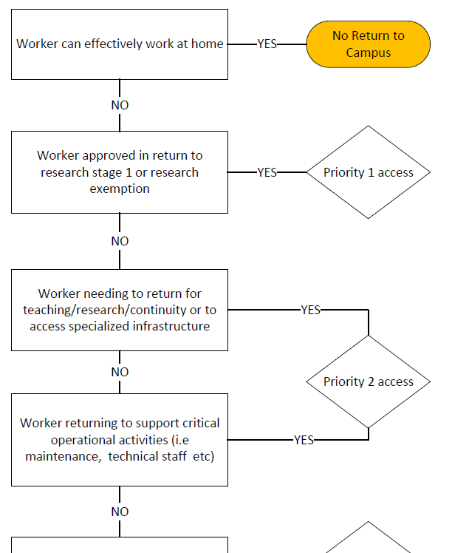
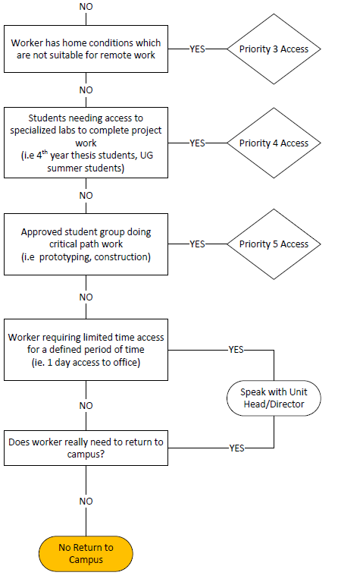

Appendix B:
On the following pages: Black and red areas are lab spaces, meeting rooms and student desk spaces that will not be opened during Stage 2. These are:
Basement: 2,3,41,42,46,47A, 61C/D,70 A/B/C, 73, unfinished shell space.
First floor: Meeting room 188, 103, 124B.
Room 188 is used to store PPE ordered by AMPEL and QMI, and will be accessed occasionally by those authorized, one person at a time.
Second floor: Meeting room 203,288
Third floor: 303,322,388
4th Floor: Meeting room 488 – which will instead be used as a temporary office for Pinder Dosanjh, Operations Manager, SBQMI.
Fifth floor: Mechanical

In addition, most offices and office spaces will not need cleaning. The exceptions are: 117,161, 161A,219,318,417, 468-478 (will remain open for occasional single occupancy use, for technical staff, building manager, clear room director, SBQMI Operations Manager).

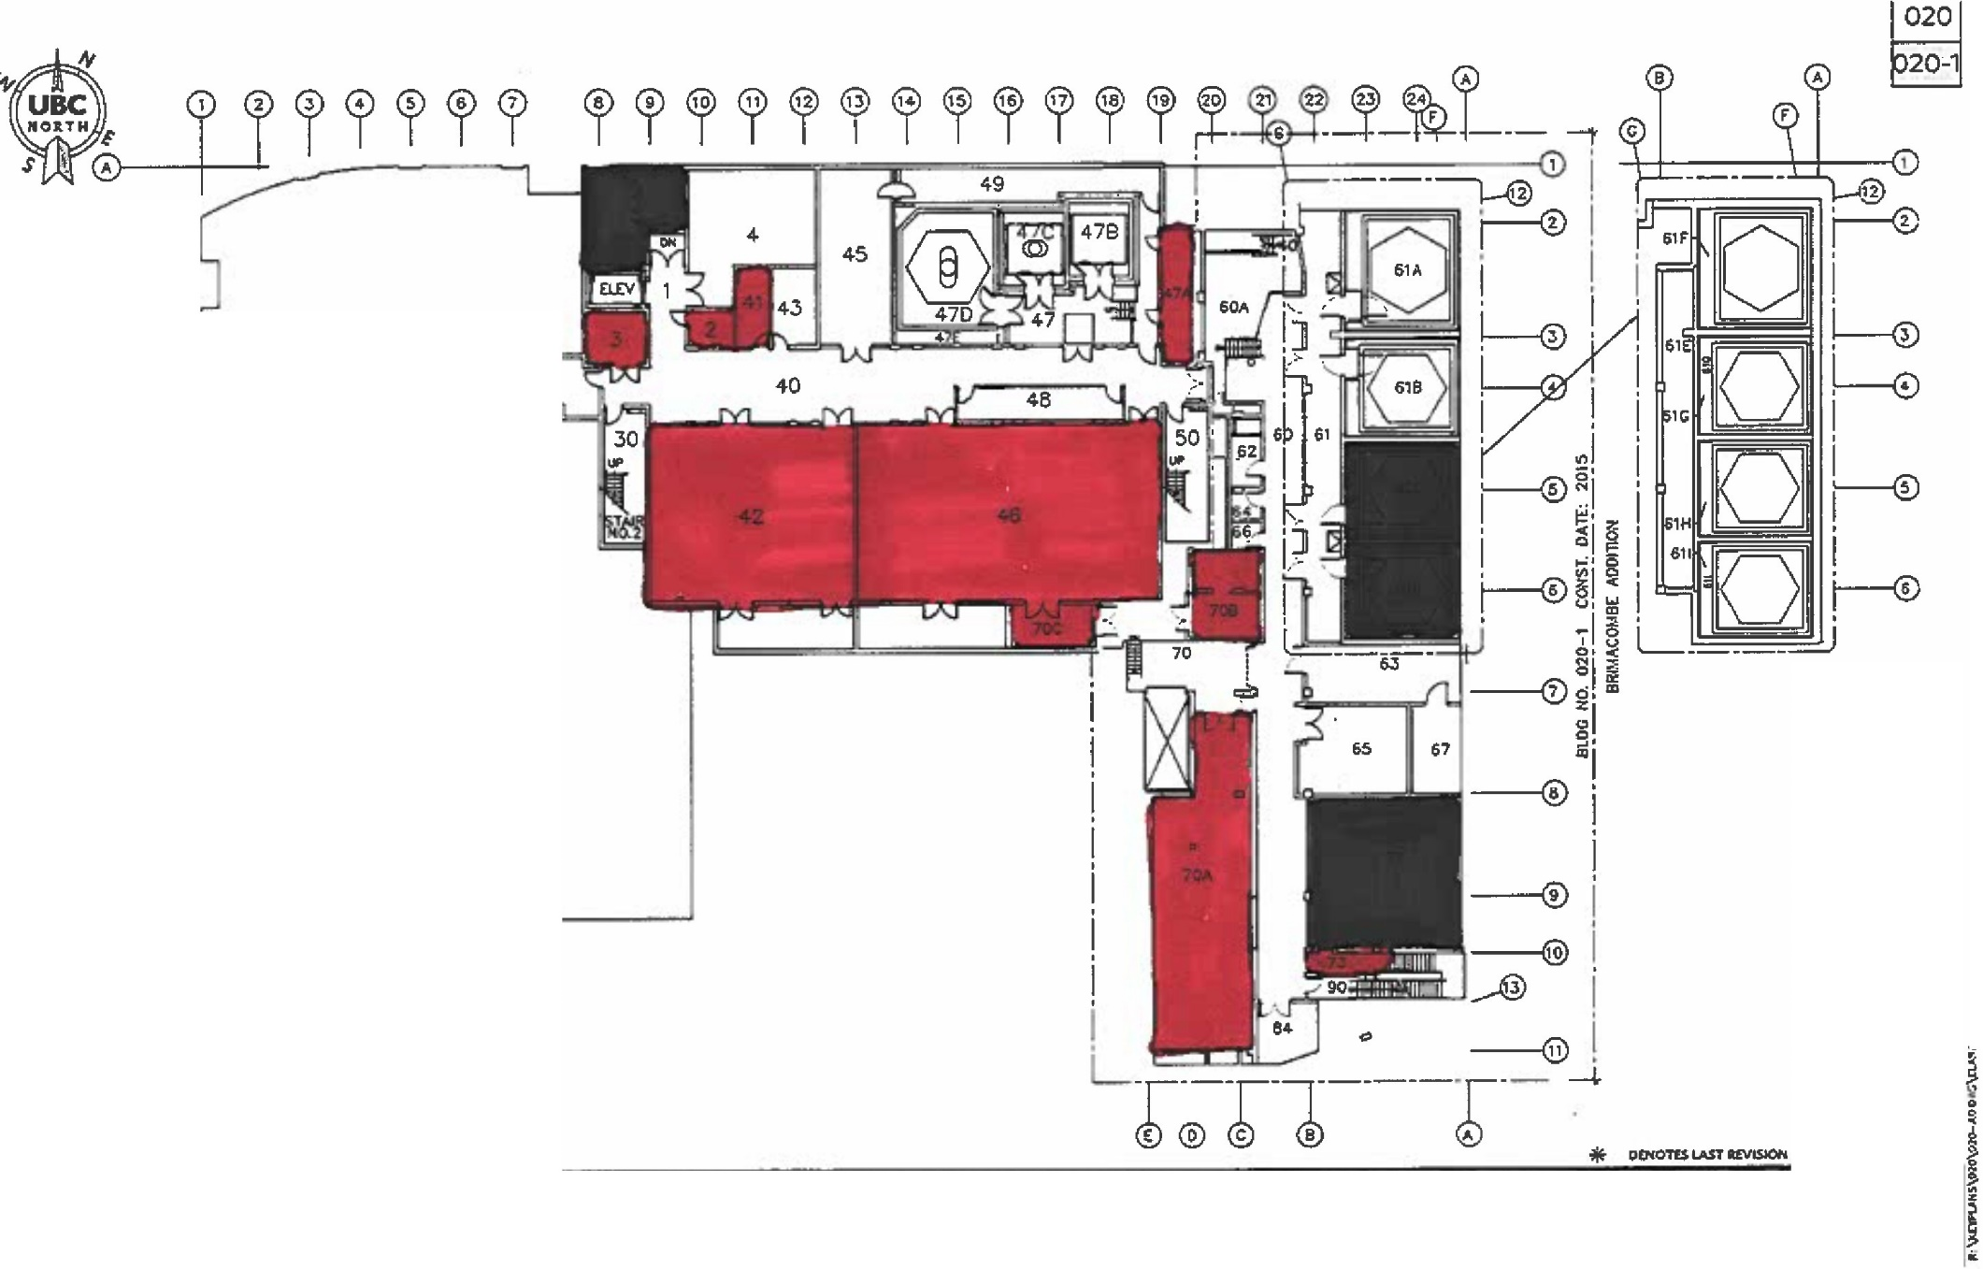
Basement

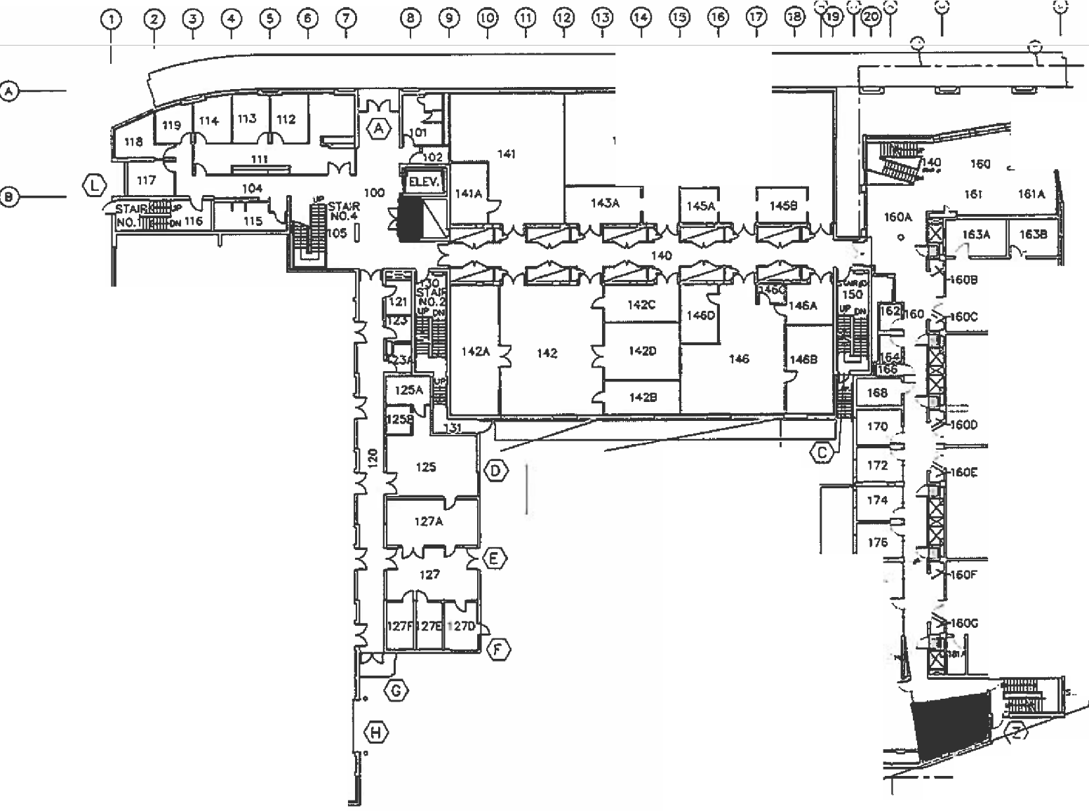
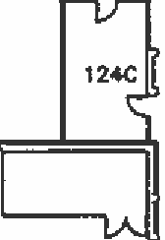
1st Floor
--
143
145
, sru:' @
, -
- .,.-
; ·
©-­
@r--
8
124
163
®-=
©-­
®--
0--­
©-­
(D--
169
I
I
17.3
122
I
0-----,::
®----=
! ]
i ]
I ]
181
0
!
©-­
©--
0-----
UL
. 186

190
I
, D
-,-------
.

Second Floor
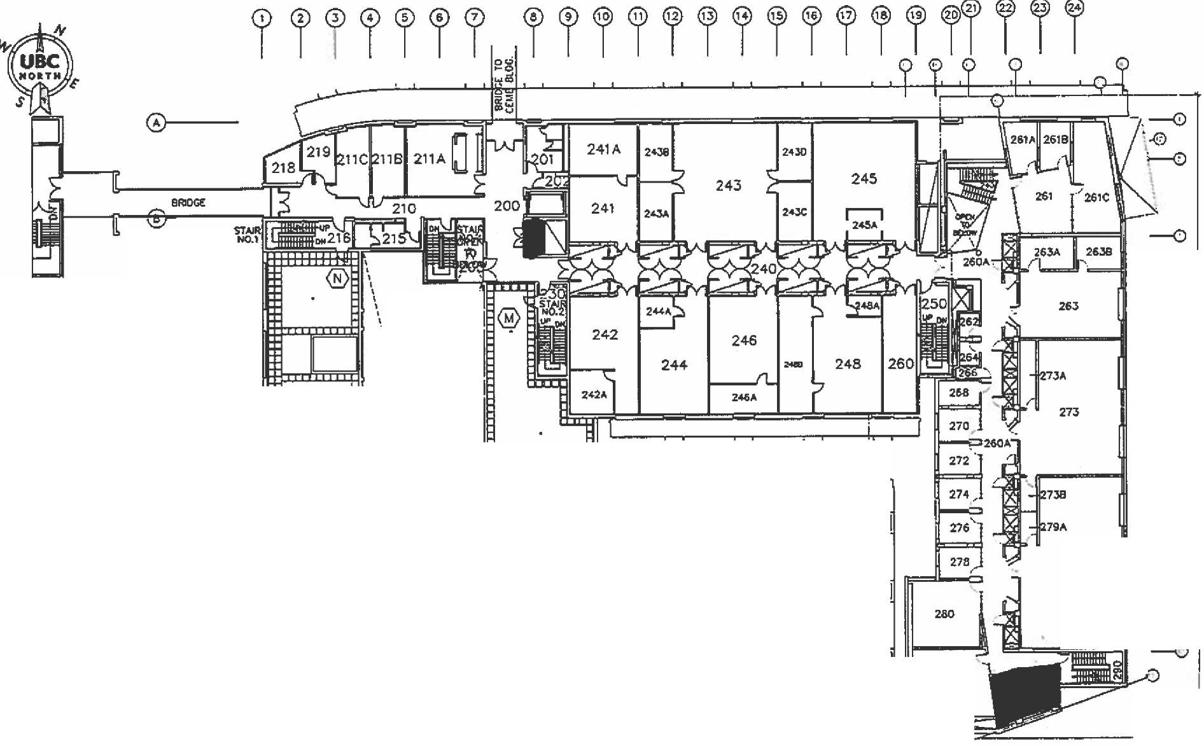
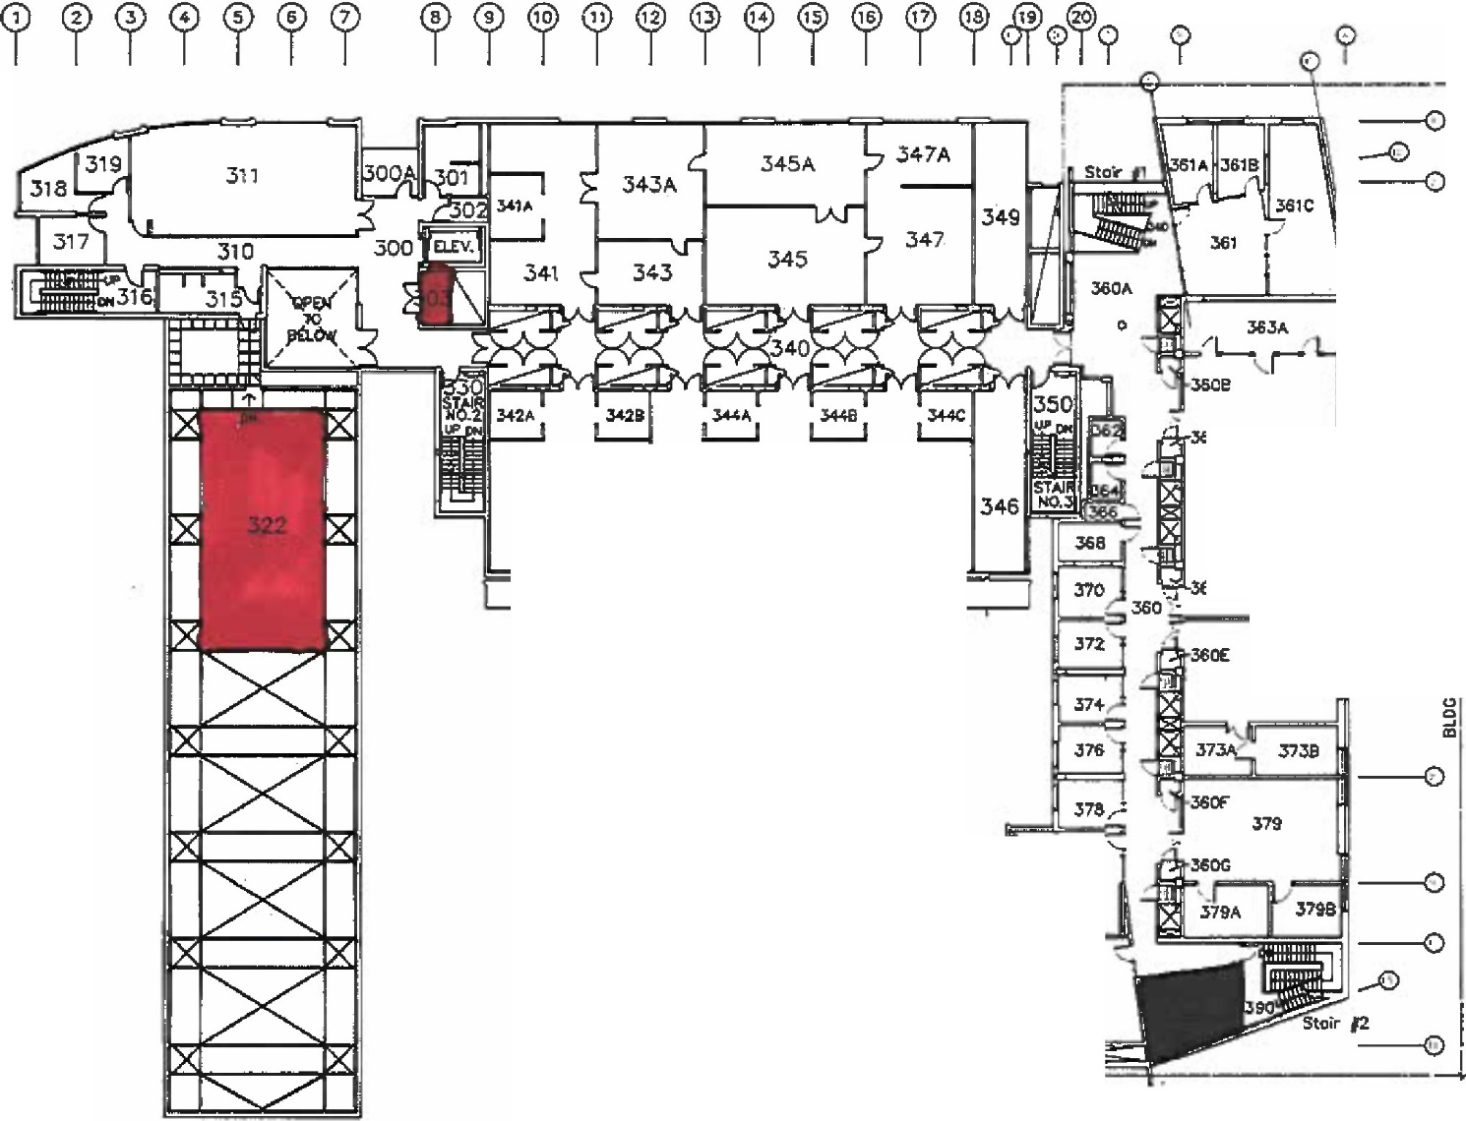
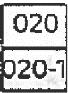
Third Floor

Fourth Floor
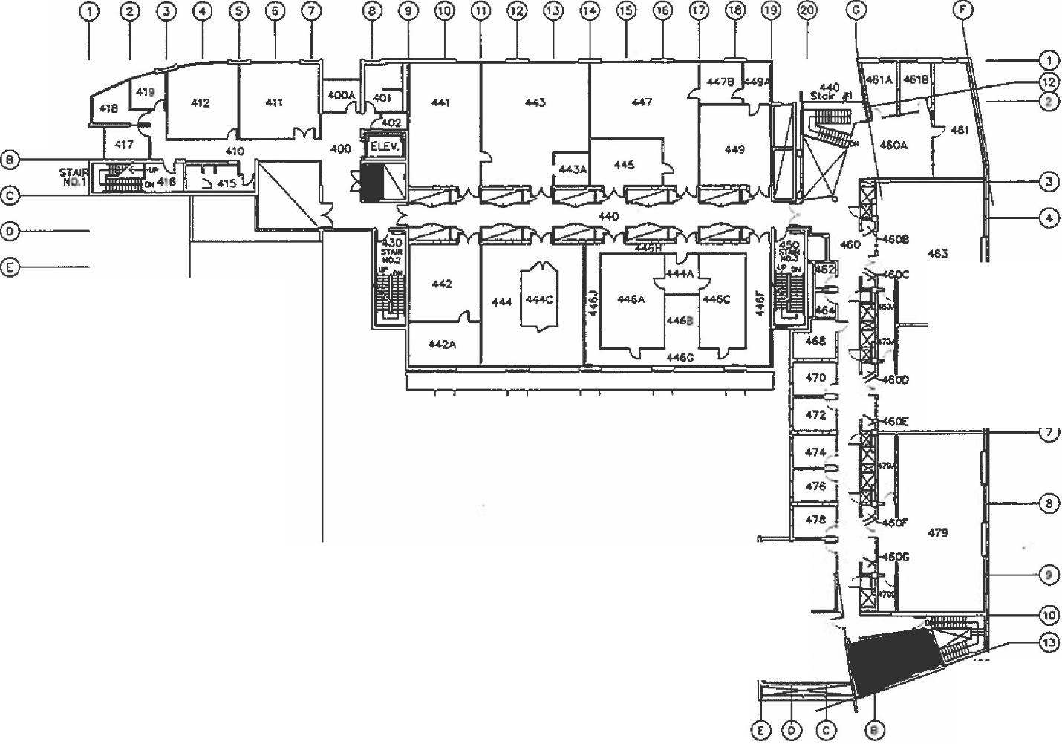
0-
©., .
©--­
®---
0., .
©--­
CD--­
@---
1111 IS
,73
®--­
®--­
®--­
®--­
®---
0--
4!lO
482
sti. sof211

A

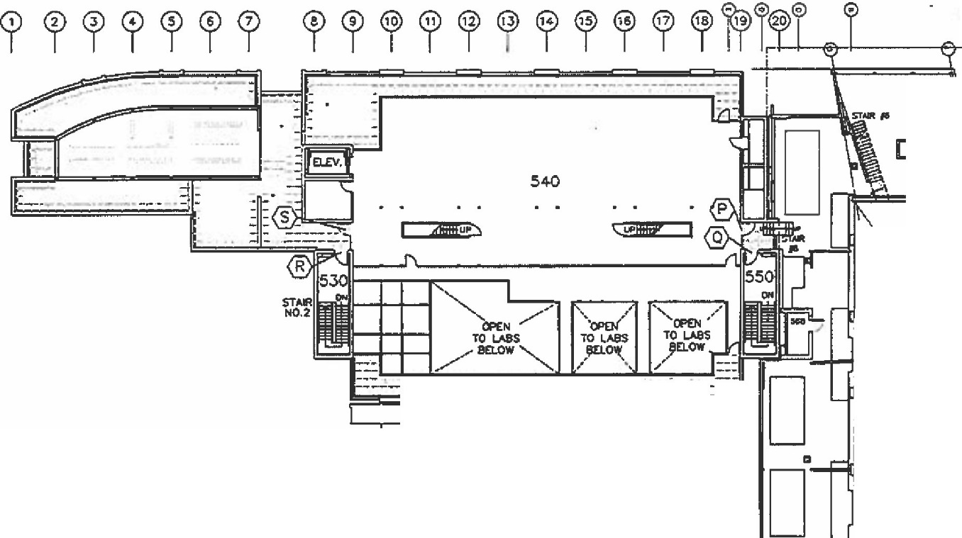
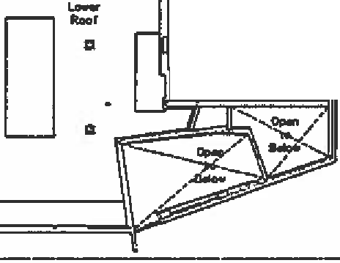
Fifth floor (Mechanical)

APPENDIX C: Indoor Mask Exceptions

General Exceptions

- Persons unable to wear a mask due to a health condition, including physical, behavioural, psychological or cognitive impairment;

- Persons unable to put on or remove a mask without the assistance of another person;

- Where communication requires that a person be able to see the speaker’s mouth;

- If the mask is removed temporarily for the purposes of identifying the person wearing it;

- Children five years of age or younger are not required to wear a mask, although children over the age of two years should do so if possible. Note that certain locations at UBC (for example those operated by UBC Childcare Services) may have more detailed rules with respect to children wearing masks;

- Persons consuming food or beverages while seated in UBC dining facilities in seating areas designated for consuming food or beverages in accordance with an approved COVID-19 Safety Plan;

- While receiving a service from a health professional, if removing the face covering is necessary in order to receive the service;

- UBC faculty or staff or other persons assisting with a health or safety emergency;

- While on residence property residents of residences operated by Student Housing and Community Services in Vancouver and Student Housing and Hospitality Service in Kelowna are not subject to these Campus COVID-19 Rules but must comply with the housing specific rules for their residence area.

Third Parties on Campus

- These COVID-19 Campus Rules apply to third parties who have been granted a short-term rental of UBC space in addition to all other applicable government safety requirements, all contractual requirements, and any approved site-specific UBC COVID-19 Safety Plan.

- These COVID-19 Campus Rules apply to third party contractors performing services for UBC in addition to all applicable government safety requirements, all contractual requirements, and any approved site- specific UBC COVID-19 Safety Plan.

Other Exceptions

- Where an exception has been provided in writing by the Executive Director, Safety & Risk Services, after consultation with the UBC COVID-19 Safety Planning Steering Committee on the Vancouver Campus or the Director, Campus Operations and Risk Management after consultation with the UBCO COVID-19 Resumption, Planning and Coordination Committee.

